# SEO RECOMMENDATIONS

## www.xxx.yy

- Set relevant meta title

*Titles are critical to giving users a quick insight into the content of a result and why it’s relevant to their query. It's often the primary piece of information used to decide which result to click on, so it's important to use high-quality titles on your web pages.*

A title tag shouldn’t exceed the 50/60 characters.

*Reference: <https://support.google.com/webmasters/answer/35624?hl=en>*

In the audited website the titles aren’t relevant, as you can see in the image below:

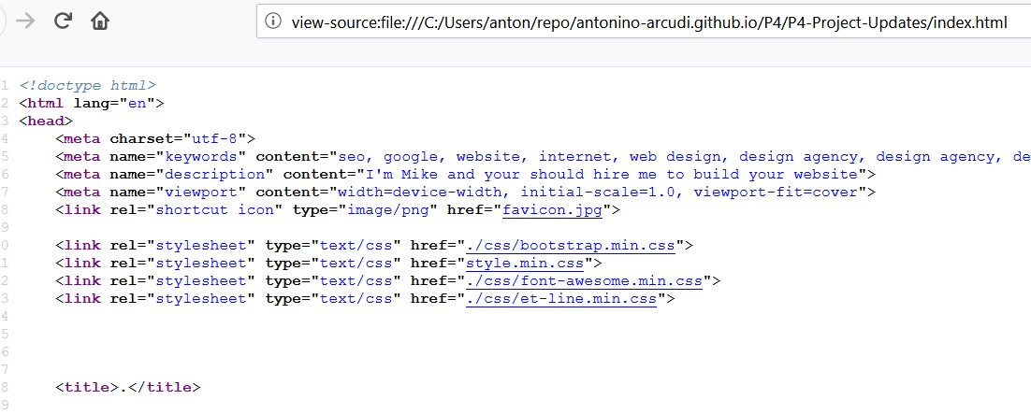

We have added relevant title to both pages bearing in mind that you would like to rank for freelance web designer Atlanta.

- Set relevant meta-description

Even if metadescription is not a direct ranking factor, it can affect the CTR in the SERP, which is one of the 200 and more ranking factors.

A meta description shouldn’t be longer than 150/160 characters.

*Reference: <https://support.google.com/webmasters/answer/35624?hl=en>*

In the contact page the meta description has no content, so we have written a metadescription.

- Removing meta keywords

The meta keyword isn’t used from Google. You can safetly remove this meta from your website: it gives clues to your competitors about your SEO strategy and it could be interpreted from search engines as a keyword stuffing signal.

*Reference: https://webmasters.googleblog.com/2009/09/google-does-not-use-keywords-meta-tag.html*

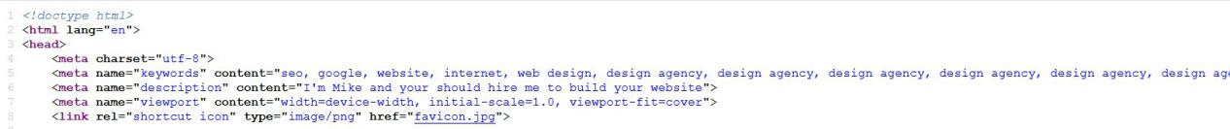

- Replace actual alt=”” text of images with a less spammy text

Image alternative text is meant to be as an indication of what and images represent. It is used by screen reader and browsers which are not able to render the images.

Reference: <https://support.google.com/webmasters/answer/114016?hl=en>

In the audited website I noticed that the alt text was used for keyword stuffing or provide no info about the image. You can insert some keywords only if they are relevant with the image content.

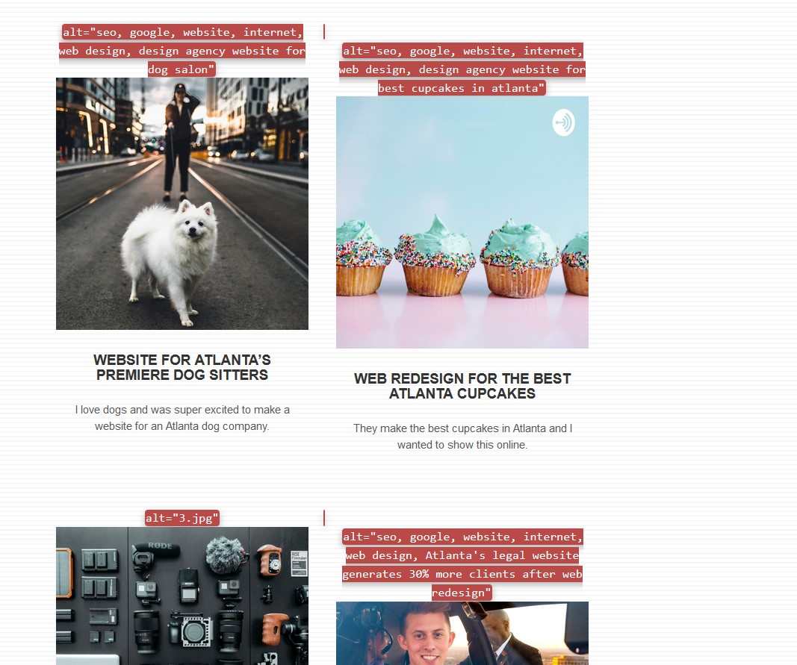

The alternative texts of the images have been changed.

- Avoid using the headings for style reasons and avoid using more than one h1 for page.

Use meaningful headings to indicate important topics, and help create a hierarchical structure for your content, making it easier for users to navigate through your document.

Avoid using the headings for style reasons and avoid using more than one h1 for page:

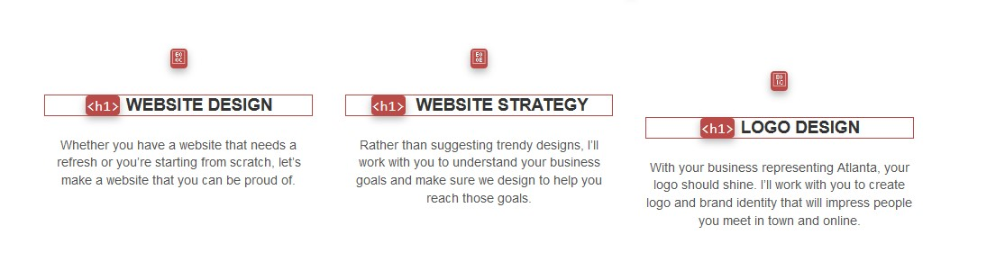

The <H1> not used for structure the content where changed to H3

- Optimize image size, weight and format.

Pagespeed is a ranking factor for mobile websites. Using images that are too large for the viewports, too heavy, or in a non optimized format results in an increase of the website loading time.

As you can see in the following image:

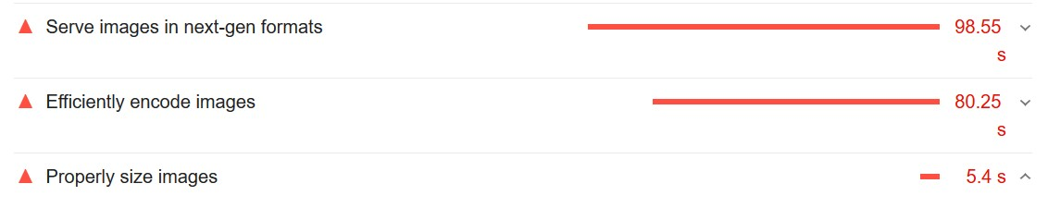

We have optimized the images size, weight and format in order to reduce the loading time of your website.

- Minify JS and CSS

- Avoid to delay the first paint of the webpage

- Avoid displaying different information to crawlers and users.

- Use the headings for structuring the content and not for style

- Don’t embed importan text inside images